

**HOMEPAGE**

**The Praetors**

CONTENTS

1 HOMEPAGE 2

# HOMEPAGE

**META TITLE**: The Praetors | Custom Mobile App Development Services

**META DESCRIPTION**: The Praetors is a top mobile app development company that designs, develops, and launches innovative iOS, Android, and web apps for startups, enterprises, and leaders.

**URL**:

**[BANNER 1]**

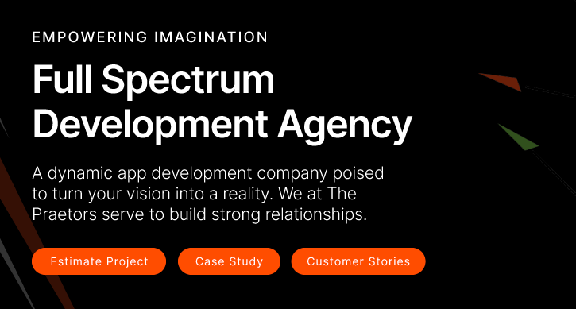

THE PRAETORS

**Leading App Development Agency in USA!**

An award-winning app development agency passionate about collaborating with organizations to create beautifully designed, expertly crafted apps that encourage brand coherence, clarity, and comprehensibility while delivering real results!

**[SCHEDULE A CONSULTATION]**

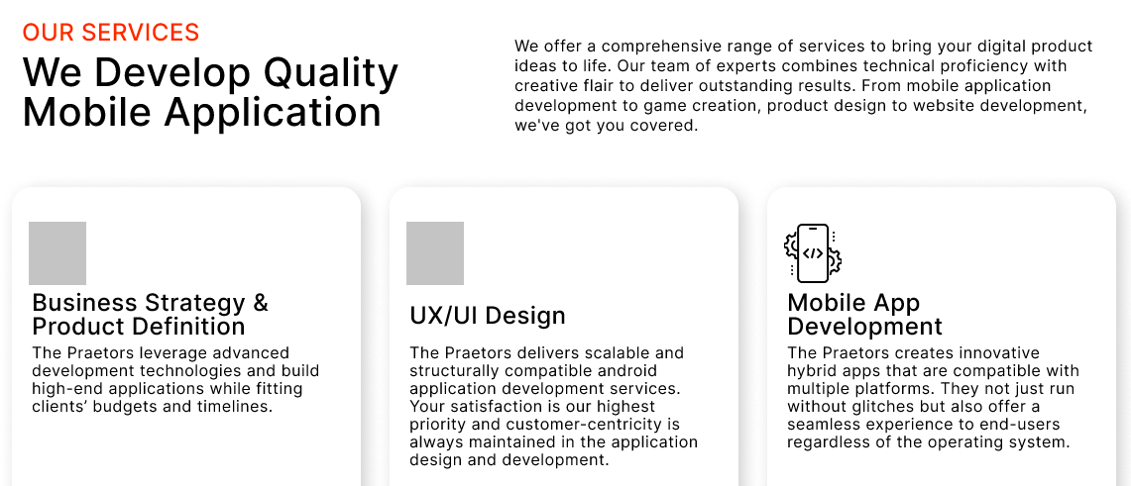

OUR SERVICES

**We Develop The Mobile Apps You Need to Succeed**

At The Praetors, we build innovative mobile apps that drive business success by engaging users and strengthening brands to perform better against the fierce market competition. For over a decade, we’ve partnered with emerging entrepreneurs, startups, and global organizations to transform ambitious visions into successful iOS, Android, and web apps.

|  |  |  |
| --- | --- | --- |
| **Hybrid Mobile App Development**  We build high-performing hybrid mobile apps using HTML, CSS, and JavaScript that efficiently deliver robust native-app functionality, quick access to device features, and seamless UX across platforms. | **Android App Development**  Our Android developers are experts at building innovative native apps leveraging the latest Android SDK, Material Design, and Kotlin to deliver super-fast, cutting-edge apps with stunning UI optimized for Android devices. | **iOS App Development**  We craft pixel-perfect iOS mobile apps that harness the full power of Swift, Objective-C, and the iOS SDK to provide immersive native app experiences with sleek UI, smooth animations, and flawless functionality on iPhone and iPad. |
| **Cross-platform App Development**  We efficiently build cross-platform apps using React Native and other frameworks to deliver a native look, feel, and speed with maximized code reuse that reduces cost and time for high-quality apps across iOS, Android, and the web. | **Flutter App Development**  For stunning native UX with portable source code, our Flutter developers create multi-platform mobile apps using Google's powerful SDK that compiles ultra-high performance on both iOS and Android devices. | **React Native App Development**  Leveraging Facebook's React Native framework, we build blazing-fast native-quality iOS and Android apps with efficient code reuse across platforms for an excellent user experience with minimal development time. |

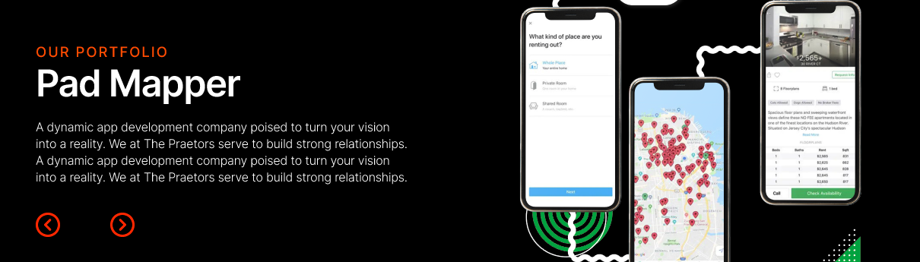

EXPLORE OUR PORTOLFIO

**Seamless Mobile App Experiences**

Our project portfolio showcases the diverse array of innovative mobile and web apps we've developed for organizations worldwide. Each case study highlights how our end-to-end services and technical expertise bring ambitious ideas to market and deliver tangible business impact through digital solutions tailored to our clients' needs. Peruse the portfolio to see examples of stunning UX design, smooth functionality, and platform-optimized performance across industries. Let the work speak for itself!

**[PORTFOLIO HERE]**

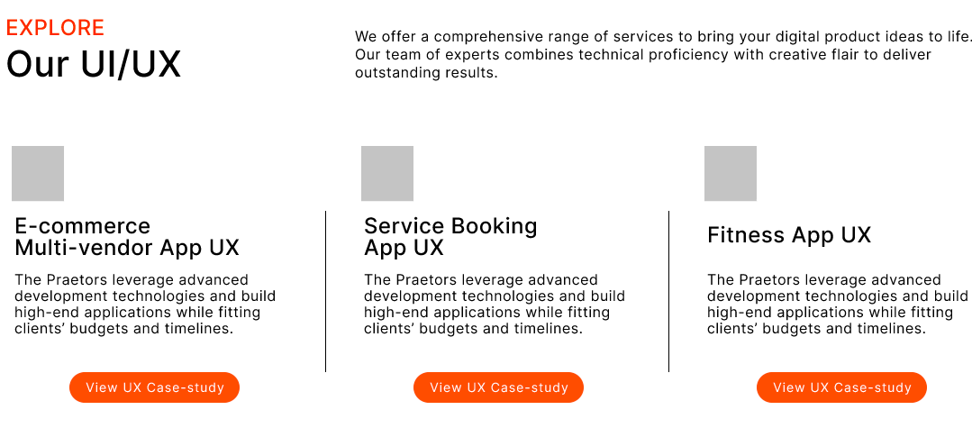

**Flawless Digital Products That Captivate!**

Whether modernizing your systems, reaching new audiences, or keeping pace with new technologies, our development teams design and build fully custom digital products aligned with your specific business objectives, using our specialized skills to create positive results.

|  |  |  |
| --- | --- | --- |
| **Business Strategy & Product Definition**  We start every app project by deeply understanding your business objectives, target users, and long-term goals to define an on-strategy product plan that sets your app up for success. Our research and planning identify how to solve your needs through app functionality that drives real results. | **UI/ UX Design**  Our user-centric design process crafts intuitive, frictionless mobile experiences tailored to resonate with your brand and audience through iterative prototyping, usability testing, and ensuring pixel-perfect ease of use. We focus on crafting stunning visuals and interactions that create joy and keep users engaged. | **Mobile App Development**  We expertly build and continuously enhance feature-rich native iOS and Android apps optimized for lightning-fast performance using agile development methods. Our technical expertise produces robust, future-proof mobile apps that feel like a natural fit for your brand. |
| **Web Application Development**  Our web app developers create progressive web apps leveraging modern frameworks optimized for speed, responsiveness, and dynamic functionality that deliver utility across devices. We build cross-platform web apps that load instantly and feel like native mobile experiences. | **Artificial Intelligence Integration**  We integrate proven AI like machine learning, computer vision, and natural language processing into your mobile apps to enable personalized, predictive experiences that naturally adapt to your users' needs. Our AI expertise helps apps learn and provide tailored value. | **App Maintenance & Support**  Through ongoing hosting, monitoring, updates, and technical support, we ensure your app delivers increasing value while meeting the evolving needs of your business and users. Our app maintenance keeps your app bug-free and compliant with the latest OS changes. |

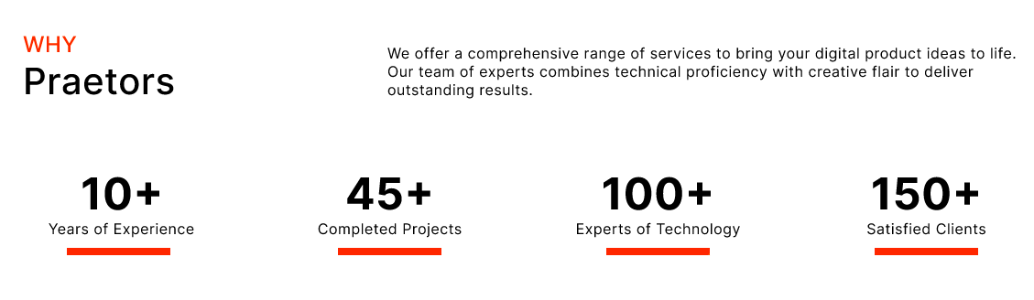

**The Praetors’ Difference**

As a top mobile app development company in the US, we immerse ourselves in understanding your vision and audience. Our nimble teams use agile development to design and develop tailored apps on time and within budget. Every design decision and line of code focuses on creating seamless, intuitive user experiences. Let us optimize your mobile presence!

|  |  |  |  |
| --- | --- | --- | --- |
| **20+**  **Years of Industry Experience** | **350+**  **Strong Team** | **75K+**  **Projects Completed** | **100%**  **Satisfaction Delivered** |

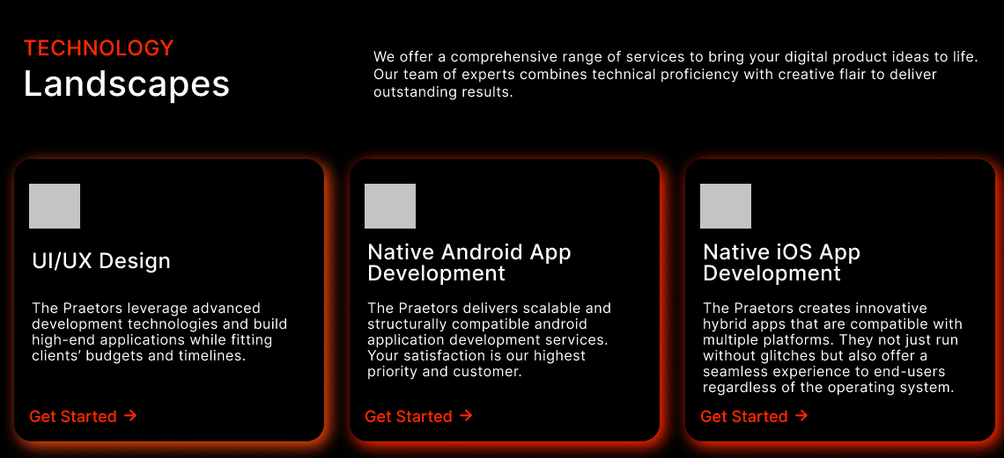

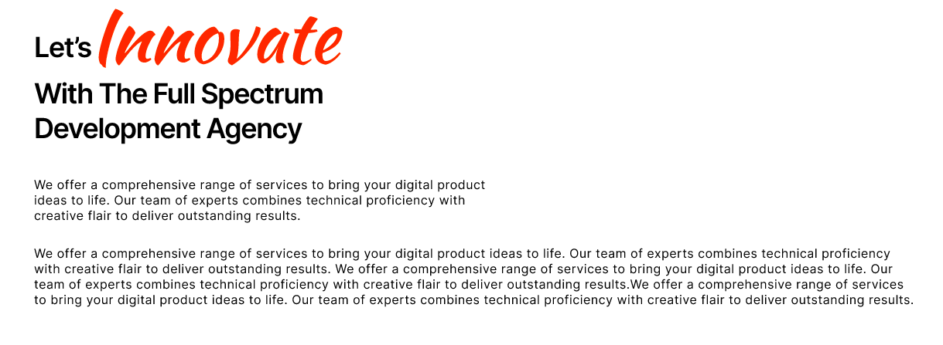

**Let’s *Innovate* With The Custom App Development Solutions**

Looking to take your business mobile? Let's build something extraordinary together. As an award-winning mobile app development company, we’re ready to collaborate with you to craft innovative, custom-designed mobile apps that uplift your brand, captivate your audience, and unlock new revenue streams.

Our end-to-end development services and proven expertise in designing stunning UI/UX set us apart. We bring deep strategic focus to understanding your business objectives, customers, and technical requirements from the start. This insight then informs our entire tailored design and development process—from conceptualizing app features aligned with your goals to implementing beautiful visuals, smooth functionality, and seamless backend integration.

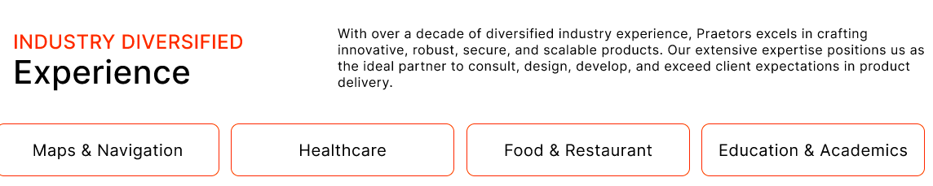

**Diversified Industry Experience**

We’ve refined our custom app development expertise across diverse industries, including healthcare, finance, retail, media, hospitality, and more. Each has unique needs, which we address through tailored solutions focused on user experience and robust functionality. Review client examples from your specific vertical to learn how our custom mobile apps solve problems and create value. Let our experience work for you!

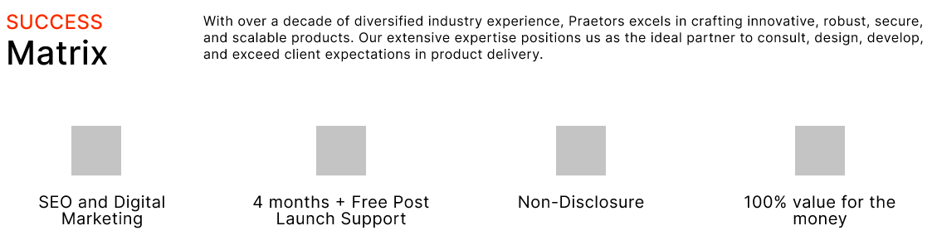

**Success Matrix**

With expertise across the full app development lifecycle, we craft custom mobile apps that solve problems, remove friction, and power your digital transformation strategy. Let’s start a conversation to explore how a new custom-designed app can help you gain a competitive advantage, delight users, and drive results for your business far into the future.

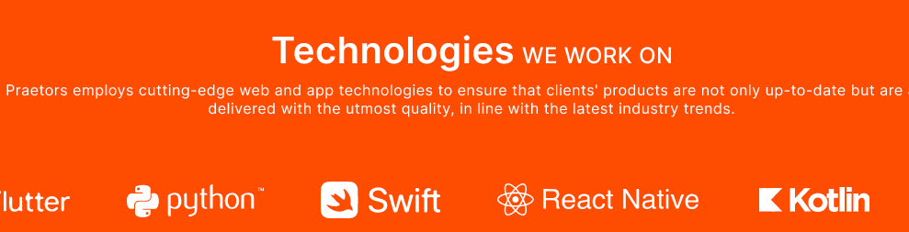

**Technologies We Work On**

Stay ahead with the latest app development trends. The Praetors explores emerging frameworks, UI patterns, development techniques, and more to consider when creating market-leading apps. Connect with us to learn how new innovations in AI, AR/VR, IoT, and machine learning are changing the digital landscape.

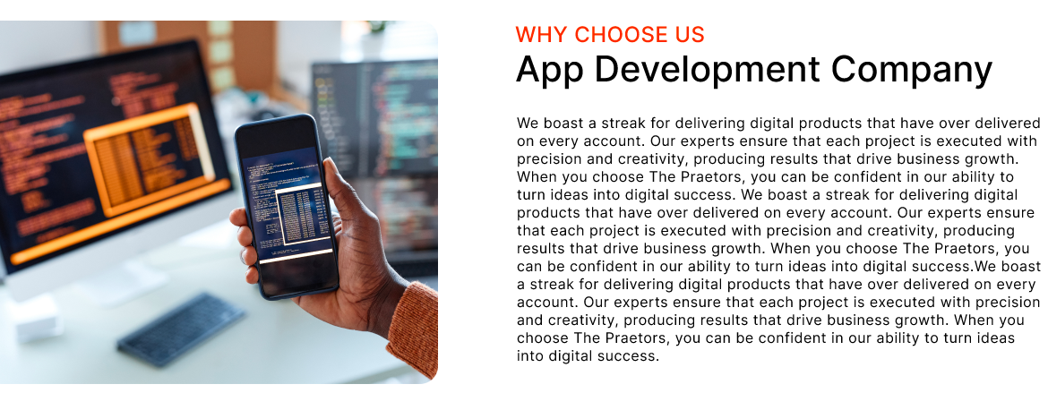

Experience The Power of Innovation

**With Leading App Development Agency**

At The Praetors, we live and breathe mobile apps. For over 2+ decades, we've worked with businesses big and small to develop custom mobile apps that engage users and deliver tangible business results. But we're not just tech geeks - we're strategic partners who care deeply about your success. Our team of talented developers, designers, and strategists will collaborate closely with you to understand your vision, goals, and users. Using proven agile development methods, we'll bring your app idea to life with creativity, skill, and efficiency. The result? An intuitive, user-friendly mobile app that your customers will love. One that not only looks sleek but actually solves real problems and drives growth. We've done this for leading companies across industries - from financial services to healthcare, ecommerce to entertainment. Now, we're excited to make your mobile app vision a reality, too.

Let's talk about how we can craft a strategic mobile app that engages your users, stands out in the marketplace, and takes your business to the next level. The possibilities are endless when technology meets imagination - let's get started!

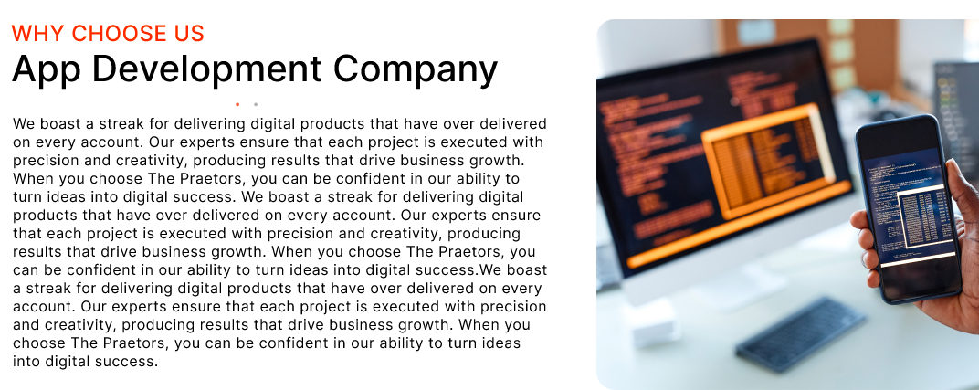

**The Tech Leader**

**Focused On Your Business Success!**

Our journey began in a humble garage over 20 years ago. Driven by creativity and a passion for technology, we grew from those modest beginnings into a leading full-cycle, mobile-first software company. Today, our diverse team of creative thinkers delivers digital innovation for top global brands and dozens of startups. But we've never forgotten our scrappy startup roots. Our focus remains on understanding clients' needs, then designing and developing custom digital products that truly deliver results.

Awards and recognitions from independent analysts are nice. But what really matters to us is the smile we put on each client's face. We aim to be their trusted partner, collaborating closely to turn visions into reality with imagination, skill, and efficiency. Our dedicated team loves what they do - which is why we have the highest satisfaction in the industry. And our delighted clients love working with us - that’s why they keep coming back again and again.

Looking ahead, our mission stays the same: to help businesses gain a competitive edge with outstanding design, quality digital products, and the power of emerging technologies. We can't wait to see what the next 20 years bring! But one thing is certain - we'll continue being trusted advisors on our clients' digital innovation journeys.

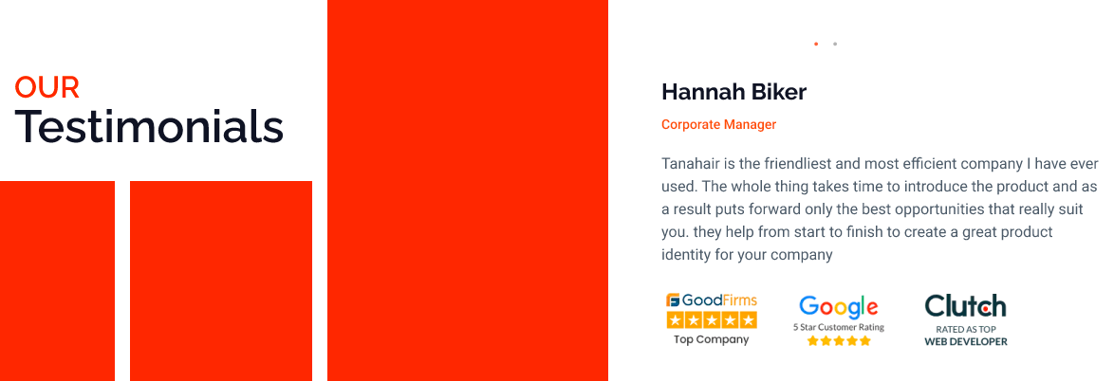

**OUR TESTIMONIALS**

**[TESTIMONIALS HERE]**

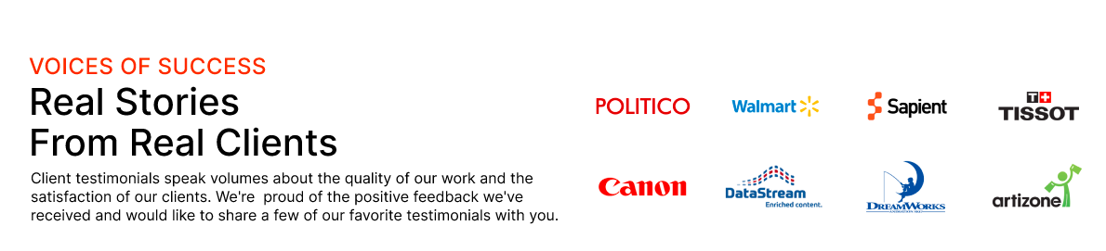

Successful Partnerships

**With Top Global Brands**

The Praetors have been trusted partners to some of the world's top global brands, collaborating to turn innovative ideas into successful digital products and services. Our proven expertise in full-cycle development, user-centric design, and emerging technologies has enabled us to build longstanding relationships with industry leaders across sectors who rely on us to gain a competitive edge and drive business growth through technology and innovation.

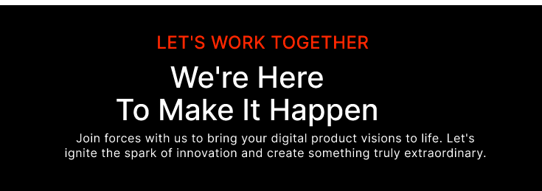

LET’S WORK TOGETHER

**We’re The Mobile Apps Development Company You Want!**

Ready to transform your mobile presence? We’re here! Get in touch to explore how we can help you better engage customers, gain a competitive edge, and unlock growth. Let's turn your app vision into reality!

**[CONTACT FORM]**